UK Year 7 – Pre-test
15 Questions | 60 minutes | Calculator allowed
1. Solve the equation.
$4x+11=39$
$x=$______________________

$\frac{3x+5}{2}$$-6=4$
$x=$______________________

2. A carpet costs $15 per square metre.
The total delivery charge is $21
Peter buys n square metres of carpet.
Circle the expression which represents the total cost in $.

$21(n+15)$
$15(n+21)$
$15n+21$
$21n+15$

3. The chart shows the number of units of electricity produced each day of the week.
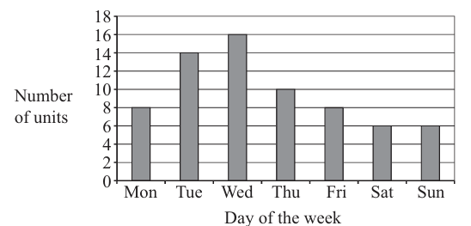
Over the seven days shown,
Calculate the total number of units produced | ________________units
Calculate the mean number of units produced per day. | ________________units

4. The table shows hourly rates of pay in a factory.
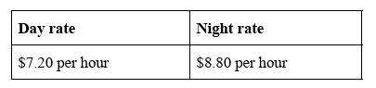
Alexine works for 6 hours during the day on Monday and for 5 hours on Tuesday night.
Calculate how much money Alexine earns altogether.

$__________________________________
5. A cuboid has dimensions 8 cm, 5 cm and 14 cm.
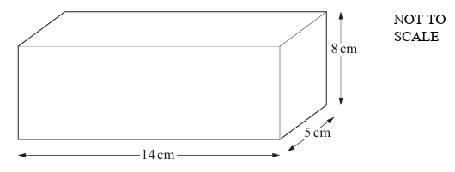
Find the volume of the cuboid.

__________________________________$cm^{3 }$

6. A teacher asks all the students in her class to write down an algebraic expression.
Julie writes down this expression: $4n-5$
The expression that Jim writes down is: $2n+14$

What value of $n$makes the value of Julie’s expression equal to the value of Jim’s expression?
You must show your working.

$n=$_________________________________
7. Pupils in Grade 7 and Grade 8 can study either Arabic, Spanish or Mandarin.
Complete the two-way table.
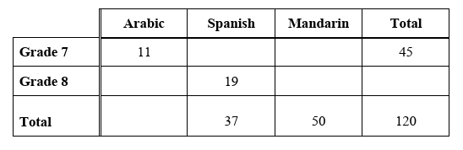
8. Look at the diagram below.
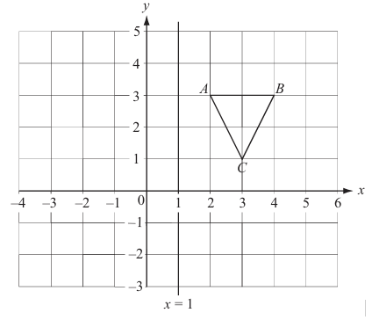
- Write down the co-ordinates of the point B. ( _________ , _________ )
- The triangle ABC is reflected in the line x = 1 to give a new triangle PQR.
Draw the new triangle PQR on the diagram above.

- The original triangle ABC is rotated 90° clockwise about the point (3, 1) to give another triangle. Write down the co-ordinates of the new position of B.
( __________ , __________ )
9. Andy, Brian and Charlie share $72 in the ratio 2 : 3 : 4
Work out how much Brian receives.

$__________________________________
10. Tim thinks of a number.
His number rounded to 2 decimal places is 5.46
What is the smallest possible number Tim could have thought of ?

_________________________________

11. Factorise $y^{2 }-8y$

_________________________________

12. The distance from the Earth to the Sun is 92 868 000 miles.
Write this distance correct to 3 significant figures.

_________________________________
13. The grid shows the straight line with equation $2x+y=12$
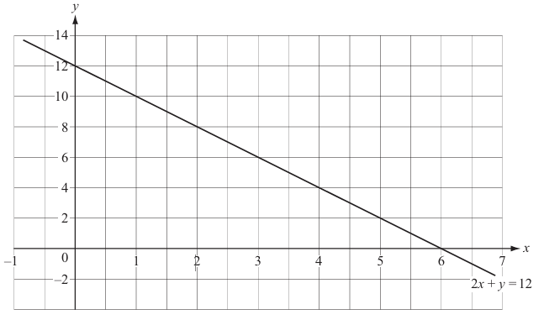
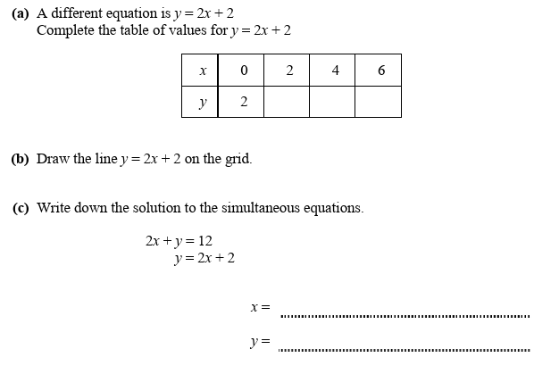

14. A baby elephant has a mass of 105 kg.
The elephant increases in mass by 95 kg per year.

Work out how many years it will take for the elephant’s mass to increase to 2 tonnes.
Give your answer to the nearest year.

_________________________________ years

15. A circular fish pond has an area of 20 $m^{2}$
Calculate the diameter of the fish pond.

_________________________________ m

